Step 1:- Unzip rockyou.txt.gz
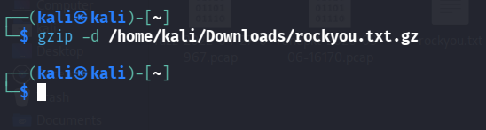

Step 2:- Write hash value in hash.txt file (nano hash.txt)
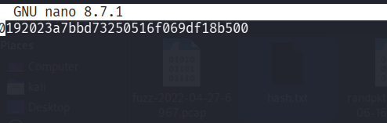

Step 3:- Run John The Ripper with password file (rockyou.txt) and hash file
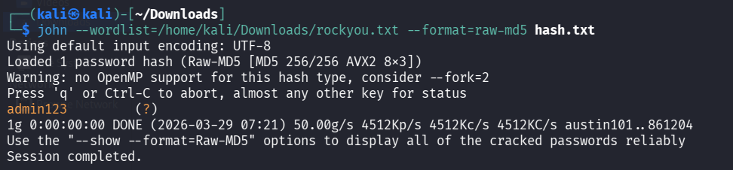

Step 4:- Check to see if the password has been cracked or not
